|  |  |  |  |
| --- | --- | --- | --- |
| **Author Name** | **Date** | **Execution Type** | **Platform** |
| Sanjay | 07/16/2020 | Regression | iPhone |

**Pop-up/Banner:**

|  |  |
| --- | --- |
| **Banner Seen** | No |
| **Learn More - Redirection** | No |

**Social Media Links:**

|  |  |  |  |  |  |
| --- | --- | --- | --- | --- | --- |
|  | [**Facebook**](https://www.facebook.com/softvisionusa) | [**Instagram**](https://www.instagram.com/softvisionteam/) | [**Twitter**](https://twitter.com/softvision_usa) | [**LinkedIn**](https://www.linkedin.com/company/softvision) | [**YouTube**](https://www.youtube.com/user/SoftVisionTeam) |
| **Footer** | Yes | Yes | Yes | Yes | Yes |

**Note:** Mark ***‘Yes’*** if the links are working and ***‘No’*** if not inside the respective cells

**Web Pages QA Summary:**

|  |  |  |  |  |
| --- | --- | --- | --- | --- |
| **Page_ID** | **Page_Group_Level** | **Page_Name and URL** | **QA Status** | **Issue Reference** |
| 1 | Level 1 | [Home](https://www.cognizantsoftvision.com/) | FAIL | DEF-1 |
| 2 | Level 1 | [Join our Team - Careers](https://www.cognizantsoftvision.com/careers/) | FAIL | DEF-2, DEF-3, DEF-4, DEF-5, DEFE-6 |
| 3 | Level 1 | [Contact +Form](https://www.cognizantsoftvision.com/contact/) | FAIL | DEF-7 |
| 4 | Level 1 | [About Us](https://www.cognizantsoftvision.com/about-us/) | FAIL | DEF-8 |
| 5 | Level 1 | [Privacy Policy](https://www.cognizantsoftvision.com/privacy-policy/) | PASS |  |
| 6 | Level 1 | [Softvision Suite](https://www.cognizantsoftvision.com/softvision-suite/) | FAIL | DEF-9 |
| 7 | Level 1 | [Our Portfolio](https://www.cognizantsoftvision.com/insights/guilds/client-stories/) |  |  |
| 8 | Level 1 | [What we do](https://www.cognizantsoftvision.com/services/) |  |  |
| 9 | Level 1 | [Our Thoughts](https://www.cognizantsoftvision.com/insights/) |  |  |
| 10 | Level 1 | [News](https://www.cognizantsoftvision.com/news/) |  |  |
| 11 | TBD | [Virtual Pods](https://www.cognizantsoftvision.com/virtual-pods/) |  |  |
| 12 | TBD | [Game of Pods](https://www.cognizantsoftvision.com/game-of-pods/) |  |  |
| 13 | Level 2 | [Insights Article](https://www.cognizantsoftvision.com/insights/) |  |  |
| 14 | Level 2 | [HWW_Guilds](https://www.cognizantsoftvision.com/guilds/) |  |  |
| 15 | Level 2 | [HWW_Pods](https://www.cognizantsoftvision.com/pods/) |  |  |
| 16 | Level 2 | [HWW_Our Approach](https://www.cognizantsoftvision.com/our-approach/) |  |  |
| 17 | Level 2 | [HWW_Studios](https://www.cognizantsoftvision.com/our-studios/) |  |  |
| 18 | Level 2 | [Join our Team - Trainings](https://www.cognizantsoftvision.com/trainings/) |  |  |
| 19 | Level 2 | [Join our Team - Women at CSV](https://www.cognizantsoftvision.com/women-at-cognizant-softvision/) |  |  |
| 20 | Level 2 | [Contact_Austin](https://www.cognizantsoftvision.com/studios/austin/) |  |  |
| 21 | Level 2 | [Contact_Las vegas](https://www.cognizantsoftvision.com/studios/las-vegas/) |  |  |
| 22 | Level 2 | [Contact_Buenos Aires](https://www.cognizantsoftvision.com/studios/buenos-aires/) |  |  |
| 23 | Level 2 | [Contact_Mysore](https://www.cognizantsoftvision.com/studios/mysore/) |  |  |
| 24 | Level 2 | [Contact_Melbourne](https://www.cognizantsoftvision.com/studios/melbourne/) |  |  |
| 25 | Level 2 | [Contact_Baia Mare](https://www.cognizantsoftvision.com/studios/baia-mare/) |  |  |
| 26 | Level 2 | [Contact_L’viv](https://www.cognizantsoftvision.com/studios/lviv/) |  |  |
| 27 | Level 2 | [Leadership](https://www.cognizantsoftvision.com/leadership/) |  |  |
| 30 | Level 2 | [SVS_ Page&square](https://www.cognizantsoftvision.com/page-square-inch-analysis-page/) |  |  |
| 31 | Level 2 | [SVS_Inventory](https://www.cognizantsoftvision.com/inventory-planning-replenishment-page/) |  |  |
| 32 | Level 2 | [SVS_Demand](https://www.cognizantsoftvision.com/demand-planning-forecasting-page/) |  |  |
| 33 | Level 2 | [SVS_Purchasing](https://www.cognizantsoftvision.com/purchasing-page/) |  |  |
| 34 | Level 2 | [SVS_Assortment](https://www.cognizantsoftvision.com/assortment-planning-page/) |  |  |
| 35 | Level 3 | [Guilds_DevOps](https://www.cognizantsoftvision.com/guilds-list/cloud-and-dev-ops/) |  |  |
| 36 | Level 3 | [Guilds_Web](https://www.cognizantsoftvision.com/guilds-list/web/) |  |  |
| 37 | Level 3 | [Guilds_Enterprise_Software](https://www.cognizantsoftvision.com/guilds-list/enterprise-software/) |  |  |
| 38 | Level 3 | [Guilds_Quality_Engineering](https://www.cognizantsoftvision.com/quality-engineering/) |  |  |
| 39 | Level 3 | [Guilds_Mobile](https://www.cognizantsoftvision.com/guilds-list/mobile-2/) |  |  |
| 40 | Level 3 | [Author Page](https://www.cognizantsoftvision.com/author/andres-angelani/)* |  |  |
| 41 | Level 3 | [Job result](https://www.cognizantsoftvision.com/careers/positions/location/all-locations/guild/all-guilds/) |  |  |
| 42 | Level 4 | [Job detail page](https://www.cognizantsoftvision.com/mobile-guild/ios-developer/8776/)* |  |  |
| 43 | TBD | [Candidate Privacy Policy](https://www.cognizantsoftvision.com/candidate-privacy-notice/) |  |  |
| 44 | TBD | [Error Page](https://www.cognizantsoftvision.com/hm) |  |  |

*Indicates Sample page since there are multiple pages of same kind.

# DEF-1 | Home | Tags are not aligned

**Description**: Tags are not aligned for the Locations.

**Steps to reproduce:**

1. Open [Home](https://www.cognizantsoftvision.com/) page.
2. Scroll down and click **United States.**
3. Observe the **Locations**.

**Note:** Same issue observed on **Europe** and **Asia**.

**Expected:** Tags should be aligned as per the design

**Actual:** Tags are not aligned

**Reference:**

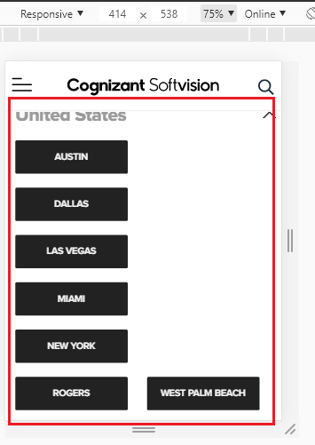

# DEF-2 | Join our Team-Careers | Extension of the file format not seen

**Description:** When tried to apply for a particular job profile without a resume the file extension is not seen completely

**Steps to reproduce:**

1. Click on <https://www.cognizantsoftvision.com/enterprise-software-guild/full-stack-net-engineer/2622/>
2. Click on proceed
3. Scroll down and Apply
4. Fill the form without resume attached
5. Check on “I ‘m not a Robot”
6. And observe below upload resume button

**Expected:** Extension of the file format should be seen completely

**Actual:** Extension of the file format not seen completely

**Note:** Observe in all available Jobs

**Reference:**

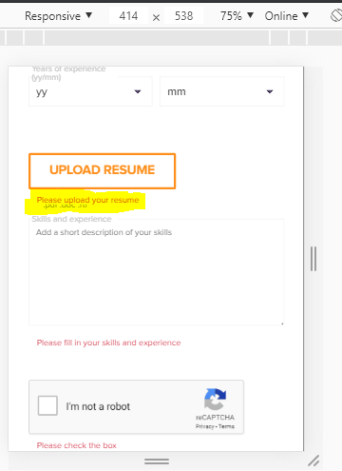

# DEF-3 | Careers | “I‘m not a robot” is inconsistent

**Description: T**o check the check box of “I‘m not a robot” it behaves inconsistent and “ I am not a robot” captcha questions are not asked on iPhone

**Steps to reproduce:**

1. Click on <https://www.cognizantsoftvision.com/enterprise-software-guild/full-stack-net-engineer/2622/>
2. Click on proceed
3. Scroll down and Apply
4. Fill the form without resume attached
5. Check on “I ‘m not a robot”
6. And observe

**Expected:** **T**o check the check box of “I ‘m not a robot” it should allow with the captcha questions

**Actual: T**o check the check box of “I ‘m not a robot” it might or might not allow and the captcha questions are not asked

**Reference:**

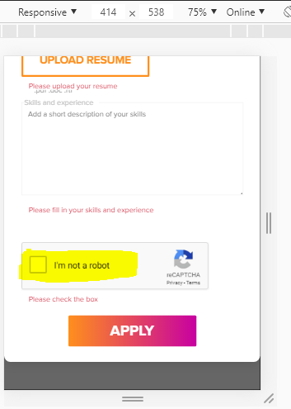

# DEF-4 | Career | Discrepancy observed after footer

**Description**: If we search for Bangalore location we must get only Bangalore location but we are getting Mysore in the title which leads to confusion

**Steps to reproduce:**

1. Go to <https://www.cognizantsoftvision.com/careers/positions/location/bangalore/guild/all-guilds/> (Career page)
2. Select Studios/Location as Bangalore
3. Check the result

**Expected:**  Vacancies in Bangalore Location should be shown as there was a filter only for Bangalore location

**Actual:** In title we have (Mysore) but filter applied is only for Bangalore location which leads to confusion

**Reference:**

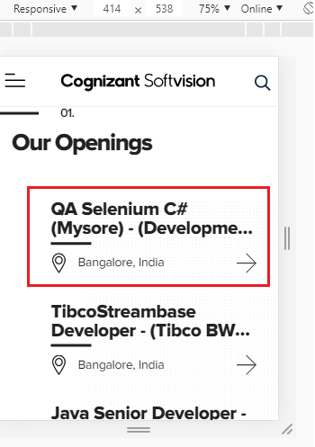

# DEF-5 | Join our Team-Careers | Link is not redirecting

**Description:** On LCA Notices pdf the links are not redirecting to its respective page

**Steps to reproduce:**

1. Go to<https://www.cognizantsoftvision.com/lca-notices/>
2. Click on any link
3. observe

**Expected:** Clicking on any link should navigate to its respective page

**Actual:** Clicking on any link is not navigating to its respective page

**Reference:**

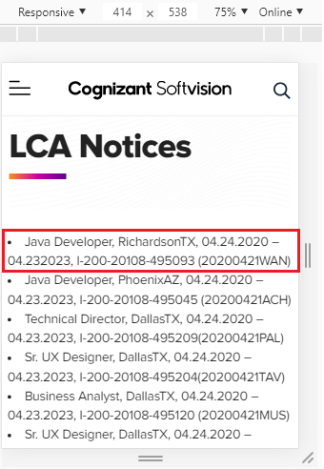

# DEF-6 | Join our Team-Careers | Button is not working

**Description**: “Get in Touch” button is not functioning

**Steps to reproduce:**

1. Go to <https://www.cognizantsoftvision.com/careers/positions/location/alpharetta-ga/guild/all-guilds/>
2. Scroll down completely
3. Click and Observe “Get in Touch” button

**Expected:**  Button should open its respective page

**Actual:** Button is not Opening its respective page

**Reference:**

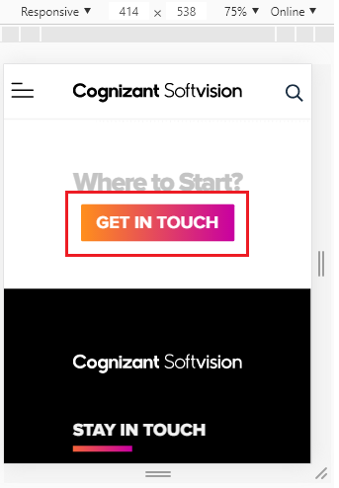

# DEF-7 | [Contact +Form](https://www.cognizantsoftvision.com/contact/) | Without attachment form can be submitted

**Description:** Without attachment, form can be submitted in contact page

**Steps to reproduce:**

1. Go to <https://www.cognizantsoftvision.com/contact/>
2. Fill the form by selecting “Work with Us (Careers)”
3. Without adding attachment submit the form
4. We receive “Thanks for submitting the form”

**Expected:** Without attachment, Form should not be submitted

**Actual:** Without attachment, Form is submitted

**Reference:**

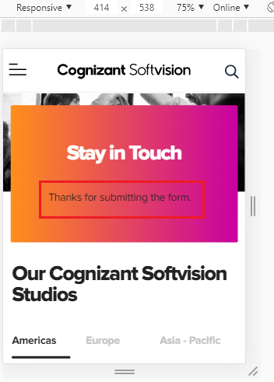

# DEF-8 | About Us| Link is not redirecting

**Description:** On Leadership the links are not redirecting to its respective page

**Steps to reproduce:**

1. Go to <https://www.cognizantsoftvision.com/about-us/>
2. Click on **Tom Delbrook** link
3. Observe

**Note:** Same issue is also observed on **Snjezana Cvoro-Begovic**, **Girish Karunakaran**, **Ines Casares**, **Mihai Constandis**, **Raul Rodila** and **David Bolcsfoldi**

**Expected:** Clicking on **Tom Delbrook** link should navigate to its respective page

**Actual:** Clicking on **Tom Delbrook** link is not navigating to its respective page

**Reference:**

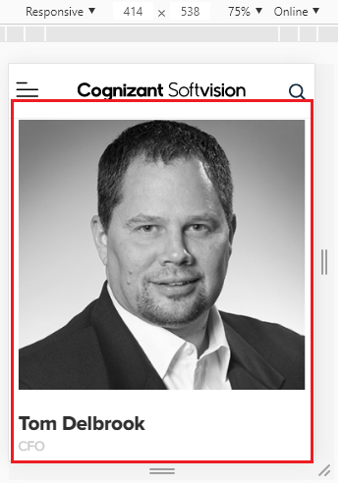

# DEF-9 | [Softvision](https://www.cognizantsoftvision.com/guilds-list/mobile-2/) Suite | “Request A Demo” Button is not working

**Description:** “Request A Demo” button is not functioning

**Steps to reproduce:**

1. Click on [Softvision Suite](https://www.cognizantsoftvision.com/softvision-suite/)
2. Scroll down
3. Click on “Request A Demo”
4. Observe

**Expected:** Button should work upon clicking it

**Actual:** Button is not working upon clicking it

**Reference:**

